|  |  |  |  |
| --- | --- | --- | --- |
| Number of applications | Credit approval rate | Agreement created | Disbursed |
| April to July : 4.7% increase | April to July : 2.1% increase | April to July : 4.7% decrease | April to July : 2.6% increase |
| May to July : 9.7% decrease | May to July : 9.9% decrease | May to july : 20.0% decrease | May to july : 20.3% decrease |
| June to July : 3.0% decrease | June to July : 5.4% decrease | June to July : 15.0 decrease | June to July : 14.8% decrease |

So we can infer from the above table that there is decrease in July when it comes to number of applications or loan disbursal so it might due to various factors:

1. Internal factors : It can consist of system or technical issues, there can also be any changes in the policy.
2. External factors : I can be related to overall economic environment change. For example, were there shifts in interest rates, economic downturns, or changes in consumer confidence that could have made people more hesitant to take loans.
3. Customer behaviour : There can be a pattern in the financial behaviour of the consumers due to vacations or reduced business activities.
4. Indian financial budget : Due to changes in the budget in the Indian market, these could include changes in interest deduction limits, tax rates on income, or other related tax implications that might impact borrowers’ decisions or the cost of loans.

**Count of users step wise**

|  |  |  |
| --- | --- | --- |
|  |  |  |
|  |  |  |
|  | |  |  |  |  |  | | --- | --- | --- | --- | --- | | Step of funnel | April | May | June | July | | Login | 11997 | 13909 | 12945 | 12558 | | Credit | 9778 | 11083 | 10554 | 9985 | | Agreement created | 1781 | 2128 | 1997 | 1698 | | Disbursed | 1640 | 2111 | 1975 | 1683 | |  | |
|  |  |  |
|  | **Percentage conversion of users step wise** |  |

|  |  |  |  |  |
| --- | --- | --- | --- | --- |
| Step of funnel | April | May | June | July |
| Login | 11997 | 13909 | 12945 | 12558 |
| Credit approved | 81.25% | 79.58% | 81.35% | 79.28% |
| Agreement created | 18.25% | 19.27% | 18.98% | 17.05% |
| Disbursed | 91.54% | 98.42% | 98.36% | 98.48% |

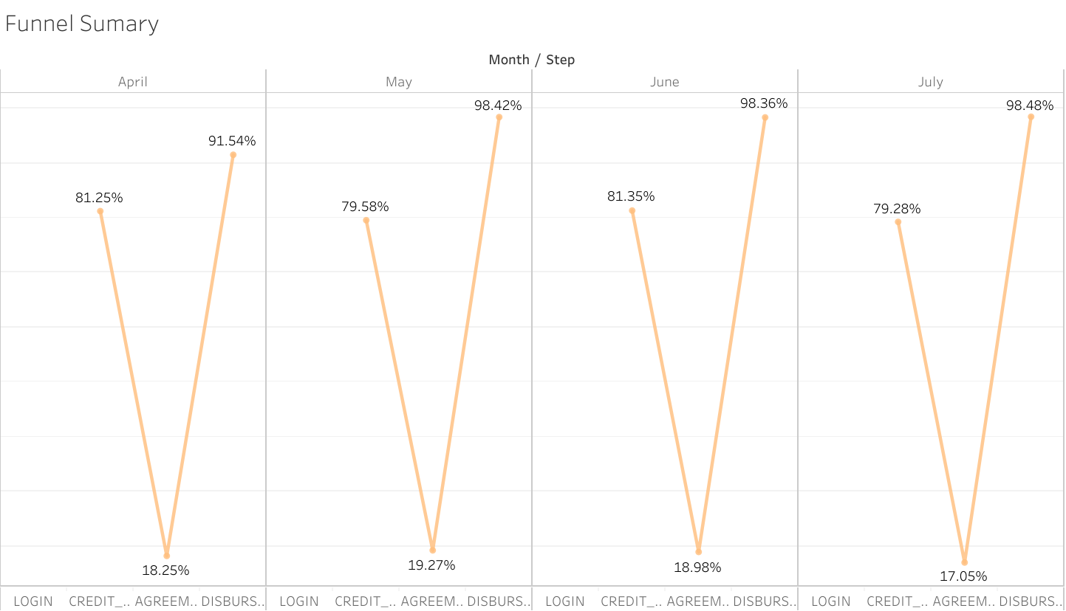

**ANALYSIS:**

1. The first table represents month on month analysis of users step wise. The trend I can infer from table is that the **number of applicants/login users were reduced in July as compared to previous months** which can be a reason for the reduced number of disbursal loans.
2. In the second table, for the step **agreement created** I can see **that there is almost a 2% difference between July and the average of the last three months** (April+may+June from **18.83% to 17.05%)** which again indicates decrease in the number of disbursements in the month of July.
3. For rest steps the numbers are more or less similar , so I think we need to focus more on the **agreement created** part and analyze the issues from both company’s and customer’s end.

**Insights:**

1. External factors such a new tax regime in the Indian financial budget may have impacted on the decision of the consumer for loans.
2. It can be related to overall economic environment change. For example, were there shifts in interest rates, economic downturns, or changes in consumer confidence that could have made people more hesitant to take loans.